**Project Report - Fitness Tracker**

**PROG10065 Group 9 Project**

**Sebastien Kennedy Inamoto**

**Kunal Bajaj**

**April 12, 2023**

**Project Overview:**

For the Group Project, we created a fitness tracking app that helps users manage their personal fitness routines. The app provides each user with a customizable “Workout Plan” which stores a collection of workouts selected by the user. Each workout is a pre-set combination of multiple exercises. This functionality allows users to maintain a plan that keeps them informed of the muscles they are working and the overall difficulty of the workout they are saving to their routine.

Both Exercises and Workouts are represented in the business logic layer of the application by C# classes, there are 2 additional classes in this layer, User and FitUserManager. The user class stores users physical information as well as a unique username, with which workout plans are given to logically connect each plan to the user that owns it. The FitUserManager manages user data as well as collects the user objects and handles the logical side of creating new users and logging existing users in.

The application uses multiple classes for data access, utilizing a data managing for each object type that is stored (user, workout, etc.) The application uses JSON serialization over CSV files due to the more streamlined implementation provided by JSON files.

In addition to the workout plan, each user will also be bound to a nutrition tracker which will allow users to enter the nutritional information of food they consume. Adding an entry to the tracker will add the values to the daily total. Both the entry and the display for the nutrition trackerare shown on the UserHomePage alongside the users physical information and a display of their current workout plan

**User Interface Design:**

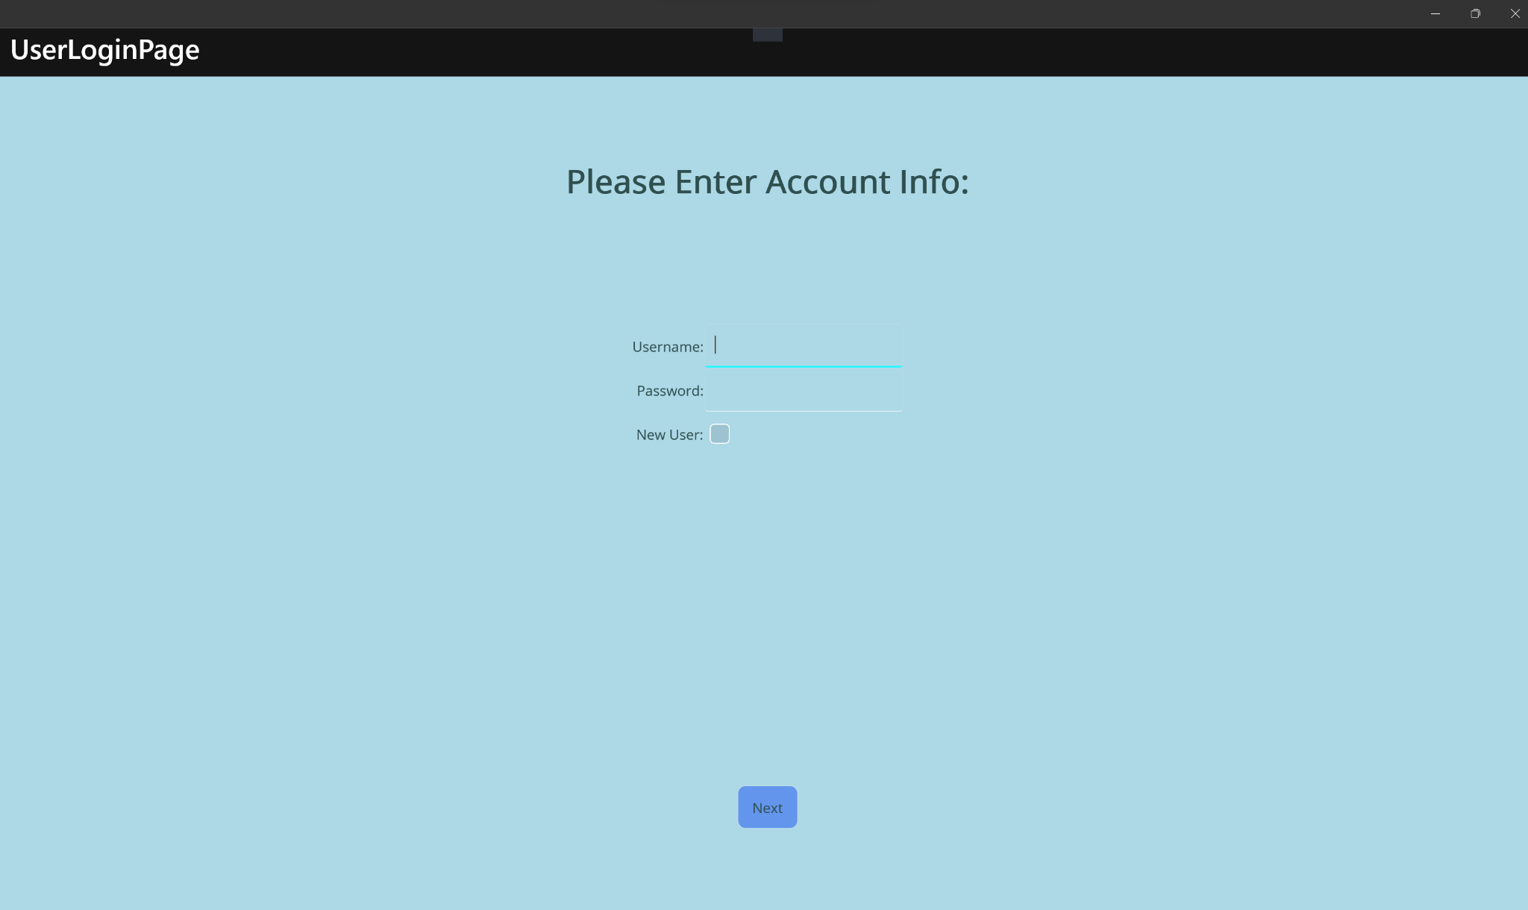

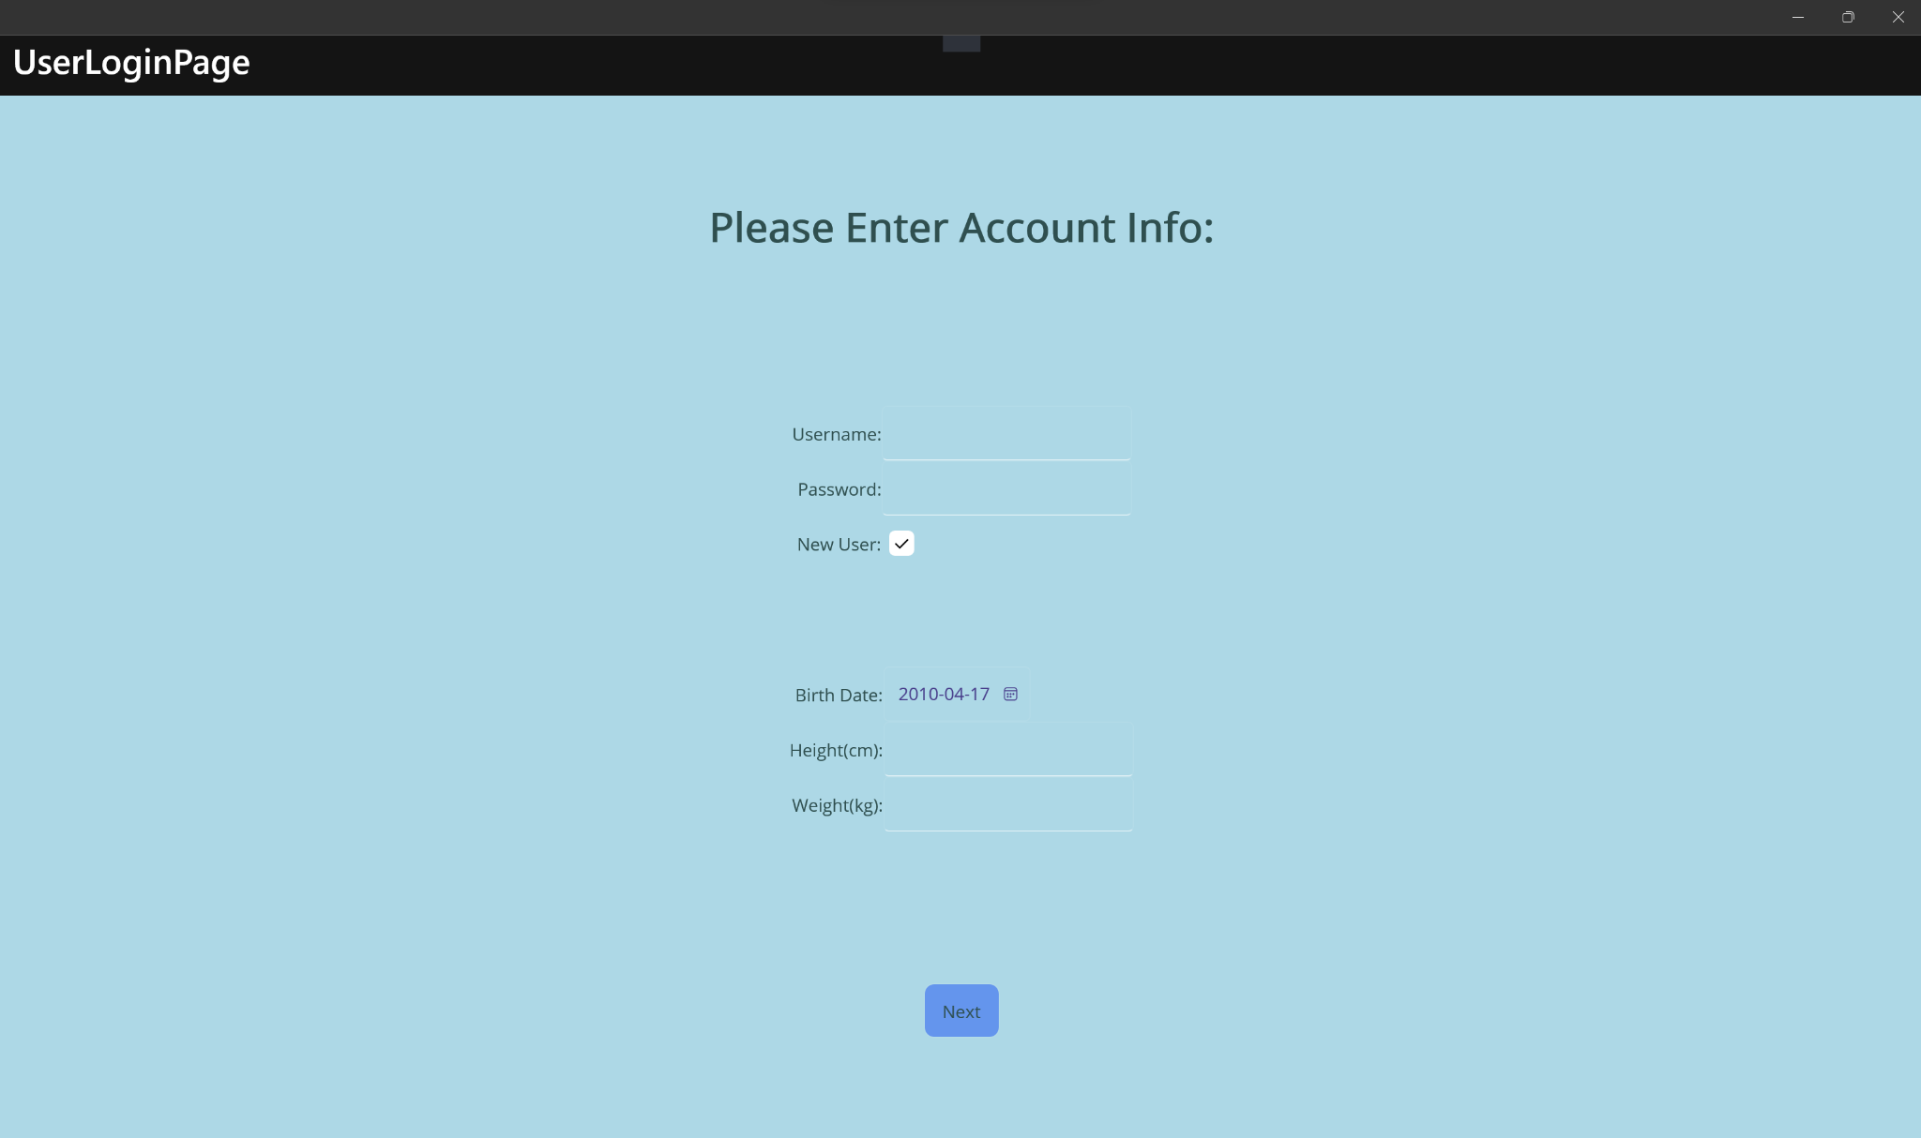

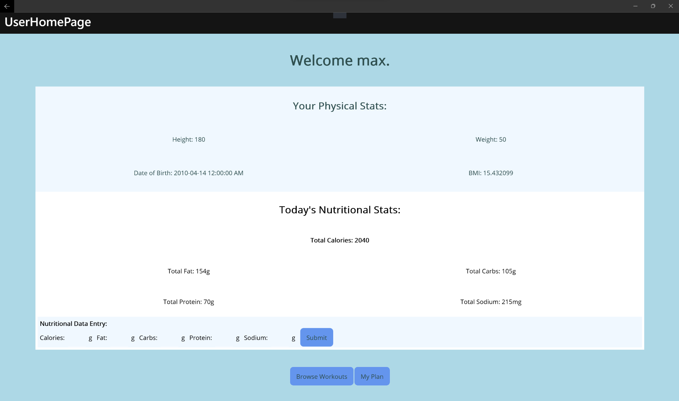

<workout screens>.

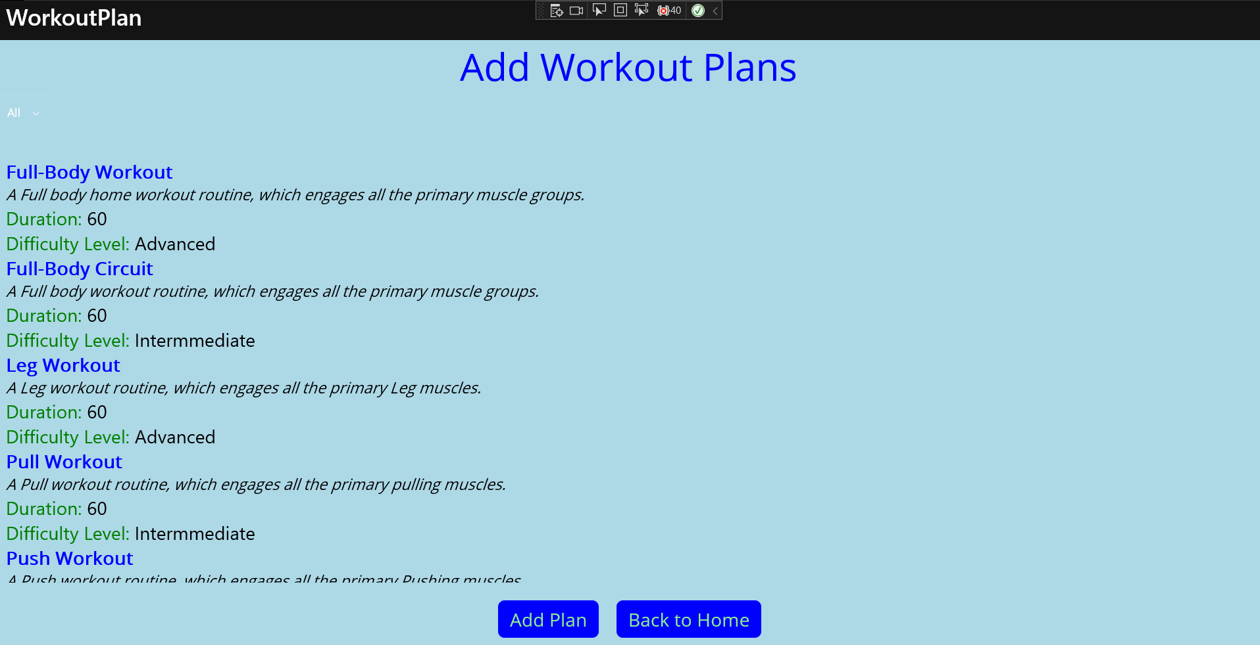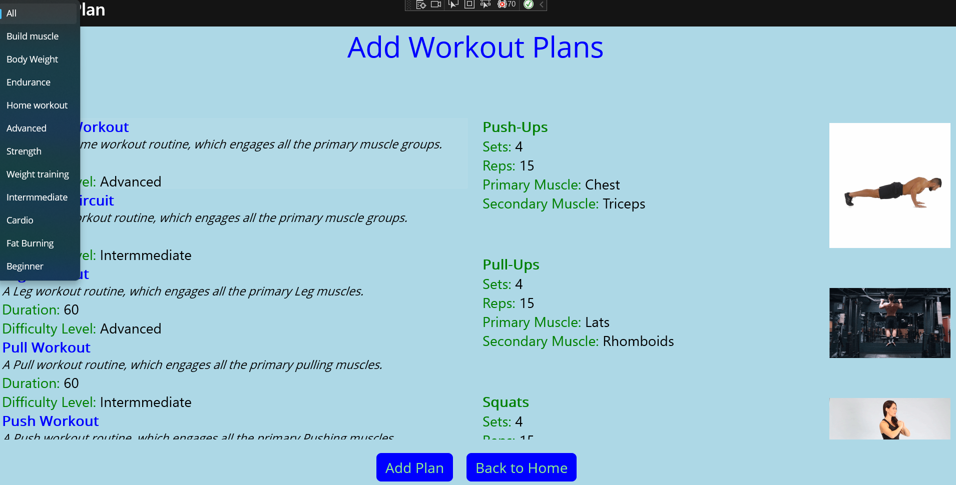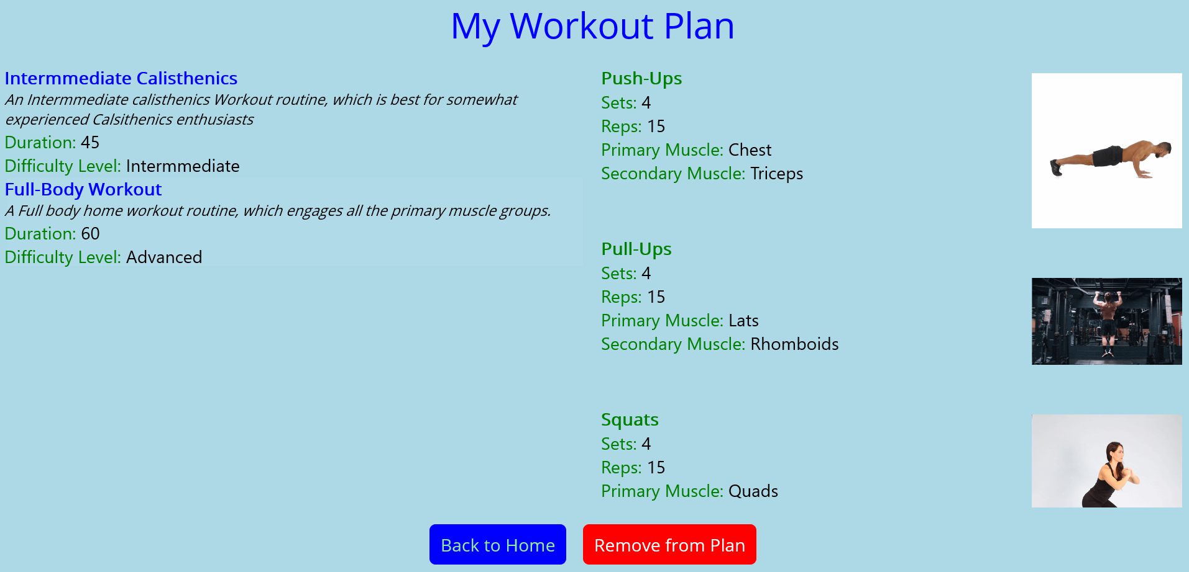

**Project Design:**

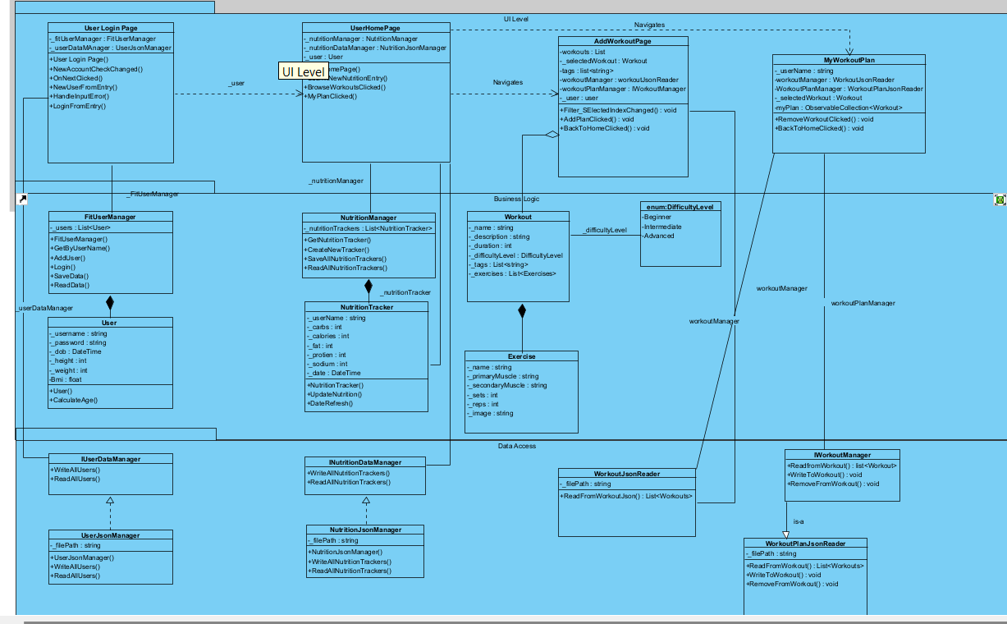

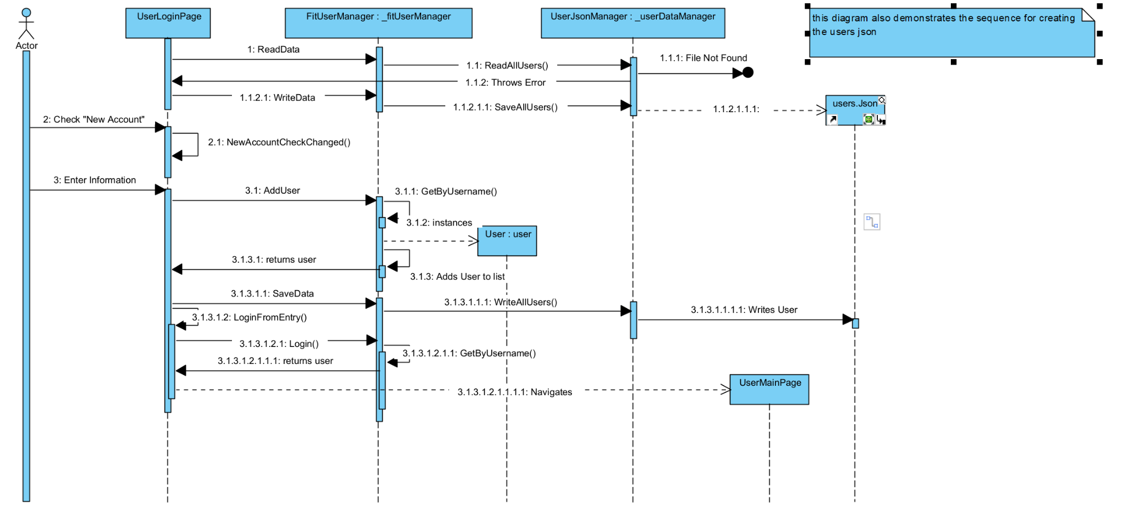

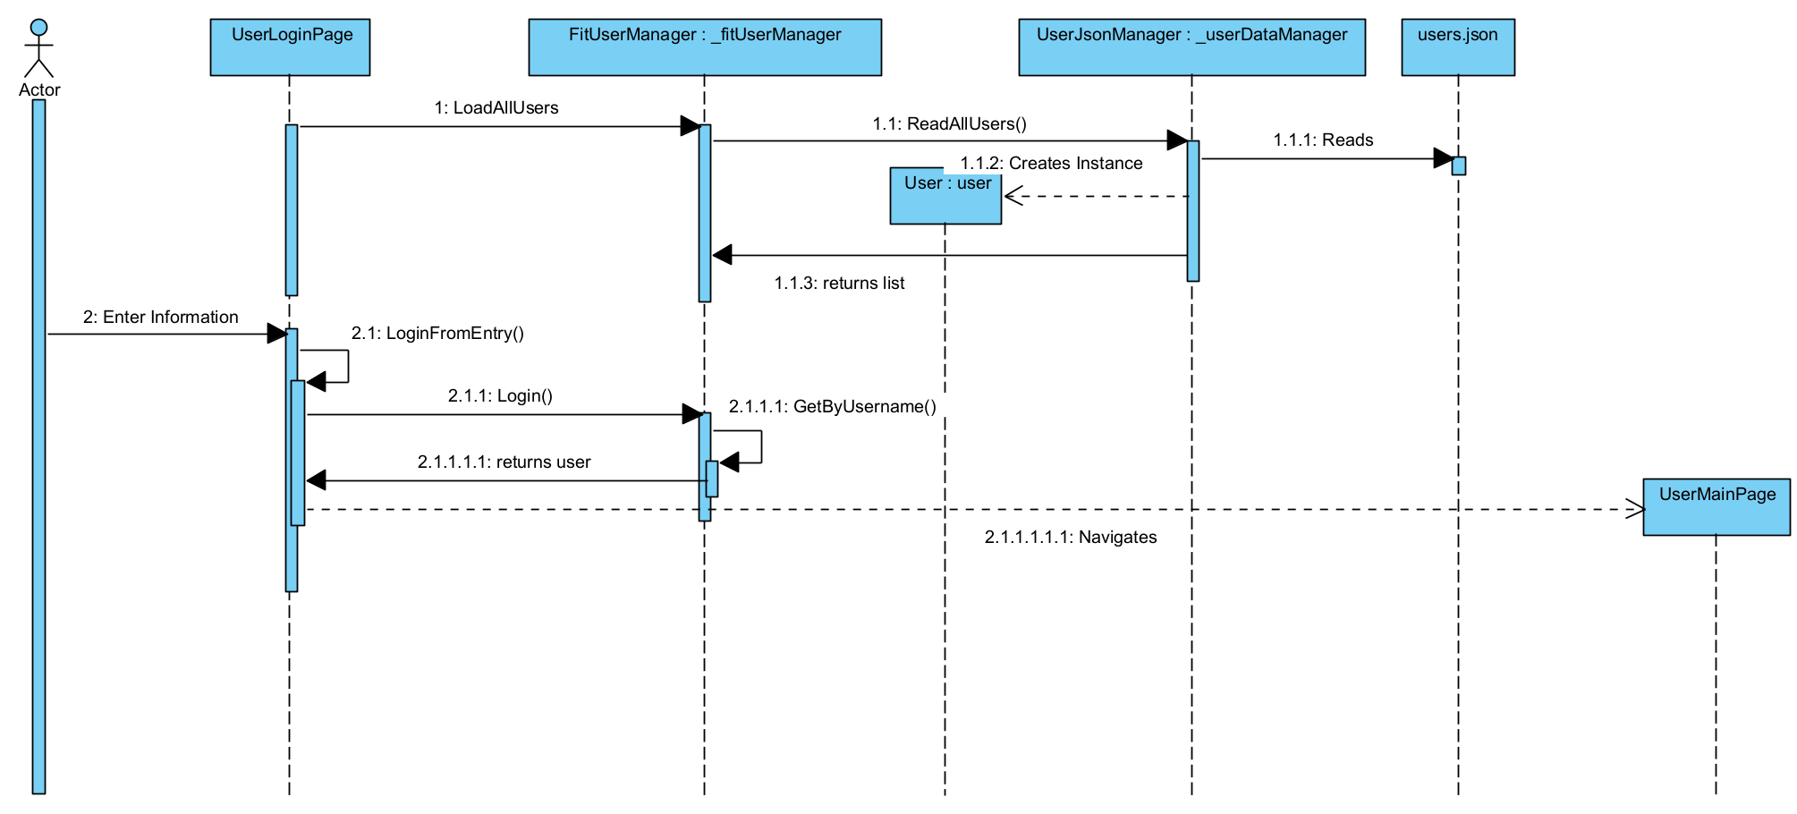

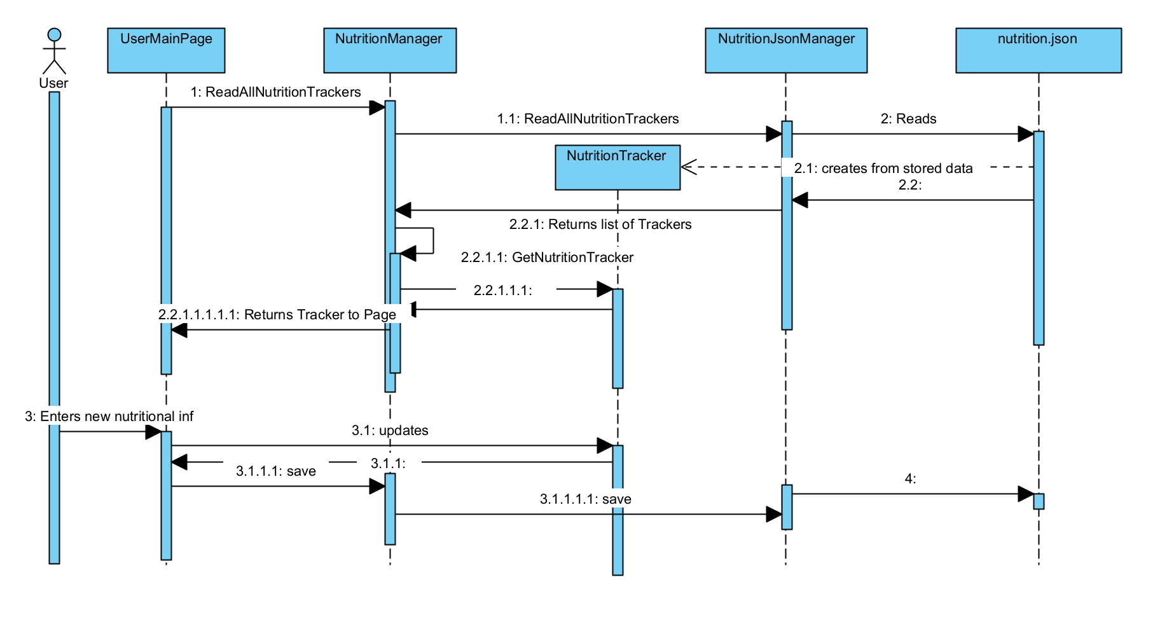

**Data Design:**

As mentioned in the overview, the application reads and writes JSON files for each persistent object type; user, workout, current nutrition.

**User:**

[{"Username":"max","Password":"max","Dob":"2010-04-14T00:00:00-04:00","Height":180,"Weight":50,"Bmi":0.0015432099}]

**Nutrition**:

[{"UserName":"max","Calories":2040,"Fat":154,"Carbs":105,"Protein":70,"Sodium":215,"Date":"2023-04-14T16:43:44.3978192-04:00"}]

**Workout:**

{

"name": "Full-Body Workout",

"description": "A Full body home workout routine, which engages all the primary muscle groups.",

"difficultyLevel": "Advanced",

"duration": "60",

"tags": [ "Build muscle", "Body Weight", "Endurance", "Home workout", "Advanced" ],

"exercises": [

{

"name": "Push-Ups",

"sets": 4,

"reps": 15,

"primaryMuscle": "Chest",

"secondaryMuscle": "Triceps",

"image": "pushups.gif"

},

{

"name": "Pull-Ups",

"sets": 4,

"reps": 15,

"primaryMuscle": "Lats",

"secondaryMuscle": "Rhomboids",

"image": "pullups.gif"

},

{

"name": "Squats",

"sets": 4,

"reps": 15,

"primaryMuscle": "Quads",

"secondaryMuscle": "Hamstrings",

"image": "homesquats.gif"

},

{

"name": "Plank",

"sets": 3,

"reps": 30,

"primaryMuscle": "Abdominals",

"secondaryMuscle": "Obliques",

"image": "plank.gif"

},

{

"name": "Dips",

"sets": 4,

"reps": 15,

"primaryMuscle": "Triceps",

"secondaryMuscle": "Chest",

"image": "dips.gif"

}

**Workout Plan:**

{"UserName":"Kunal","Workouts":["Full Body Cardio Workout","Quick Cardio","Beginner Calisthenics","Advanced Calisthenics","Full-Body Workout","Full-Body Workout","Full-Body Circuit","Intermmediate Calisthenics","Full-Body Circuit","Full-Body Workout","Full-Body Workout"]},

**Project Plan - Sebastien**

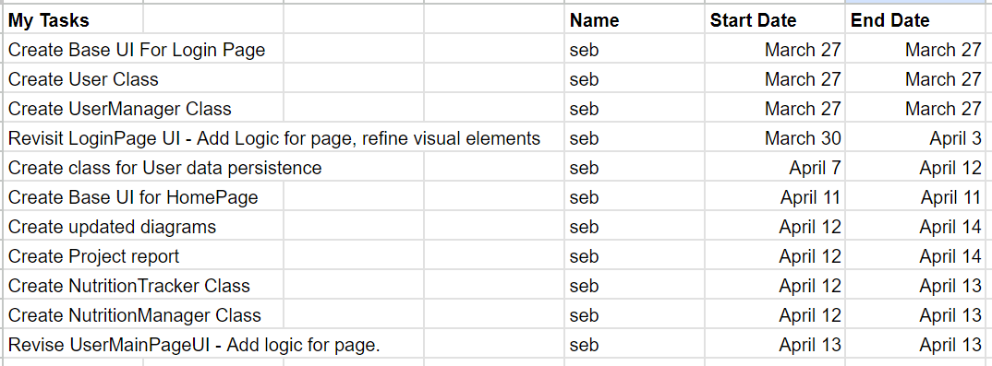

**Project Plan - Kunal**

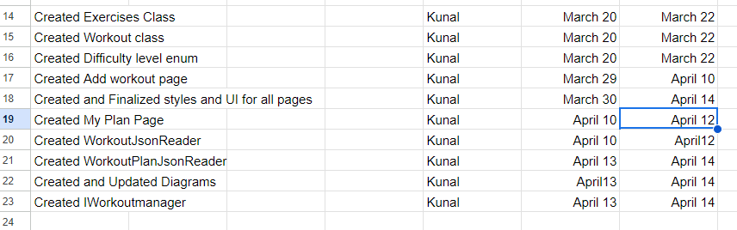

**Project Reflection** **- Sebastien**

Upon reflection, I feel that our project ended up pretty similar to its original vision from the proposal. The most major differences are the change in functionality in the workout class, which originally had one per user, and was changed during development to be used in part of the workout plan, which essentially replaces workouts intended relationship with the user. Another major change was the removal of food objects, and having the nutrition functionality simply serve to track the users daily consumption of common nutrients.

Although I don’t have a clear vision for future development, I think it might be nice to further flesh out the nutrition functionality with more advanced statistics or recommendations for daily values based on the users fitness goals.

I think the greatest difficulty in development was organizing and maintaining strong communication in order to have a more concrete idea of what our final product would look like.

During development I don’t think I necessarily learned a lot of new skills but I definitely was able to deepen my existing knowledge and abilities. Specifically with the use of information hiding and separation of concerns I feel as though working individually on separate components of an application really enforced the concepts of separation of concerns.

**Project Reflection - Kunal**

Upon Reflection, Our Project has been diverted quite a bit from its original version. Earlier version has mobile wireframes while the final project is developed for Windows Interface.

Also the major difference I believed we had was In project proposal we decided to add a functionality by which users can edit the exercises in workout plans but now only hard-coded plans are being provided to user. Earlier there was a nutrition page as well but we add that to home page only.

The things we would improve upon this project would be like I said earlier pby providing more freedom to user by letting them edit exercises in workout plans , customizable diet plans can also be added, and various UI improvements like better colour scheme, clear images, more creative controls can be added to enhance the app further.

Our greatest difficulty was communication gap during the first few weeks and it was our first project being developed in teams so it gave us quite a challenge. Researching about various syntax like binding, and using data persistence was also quite hard at first.

With this project I learned a lot about how to develop in teams, and it enhanced my core understanding on data persistence using json files and helped me learn more about syntax of C# more efficiently. It also improved my logical reasoning while creating this project.